Sentiment Analysis on Gojek App User Reviews to Identify Customer Satisfaction and Complaint Factors

**Muhammad Haikal Firdaus**  
*Information Systems Study Program*  
*Faculty of Engineering and Computer Science*  
*Universitas Komputer Indonesia*  
Bandung, Indonesia  
[muhammad.10522035@mahasiswa.unikom.ac.id](mailto:muhammad.10522035@mahasiswa.unikom.ac.id)

**Rahman Aditia**  
*Information Systems Study Program*  
*Faculty of Engineering and Computer Science*  
*Universitas Komputer Indonesia*  
Bandung, Indonesia  
[rahman.10522001@mahasiswa.unikom.ac.id](mailto:rahman.10522001@mahasiswa.unikom.ac.id)**Aditya Juliana**  
*Information Systems Study Program*  
*Faculty of Engineering and Computer Science*  
*Universitas Komputer Indonesia*  
Bandung, Indonesia  
[aditya.10522029@mahasiswa.unikom.ac.id](mailto:aditya.10522029@mahasiswa.unikom.ac.id)

**Andhika Wirayuda**  
*Information Systems Study Program*  
*Faculty of Engineering and Computer Science*  
*Universitas Komputer Indonesia*  
Bandung, Indonesia  
[andhika.10522037@mahasiswa.unikom.ac.id](mailto:andhika.10522037@mahasiswa.unikom.ac.id)

*Abstract*—*Competition in the on-demand services industry requires companies like Gojek to continuously improve the quality of services based on user feedback. Reviews on the Google Play Store are an abundant source of data for this purpose, but manual analysis is inefficient due to the sheer volume of data. This study proposes the application of data mining to automatically analyze the sentiment of Gojek application user reviews. This study uses the Naive Bayes classification method which is known to be effective for text classification tasks. The research process includes several main stages: data collection, data pre-processing for sentiment labeling, text pre-processing (tokenization, case folding, filtering stopwords), and feature weighting using TF-IDF. Model performance was evaluated using a 10-fold cross-validation scheme with accuracy, precision, and recall metrics. By analyzing thousands of reviews, this study aims to accurately identify the key factors that drive customer satisfaction and complaints, the results of which can provide strategic and actionable insights for the future development of Gojek's products and services*

Keywords— Sentiment Analysis, Data Mining, Gojek, Naive Bayes, App Reviews, Text Mining, Natural Language Processing

# Introduction

In today's digital era, on-demand service applications have become an indispensable part of the lives of urban people [1]. Gojek, as one of the pioneers in Southeast Asia, offers a variety of services ranging from transportation, food delivery, to digital payments [2]. Fierce competition in this industry requires companies to constantly innovate and improve the quality of services [3]. One of the most effective ways to measure and improve service quality is to listen to the voice of the customer [4].

User reviews available on app distribution platforms like the Google Play Store are an authentic and massive source of feedback [5]. Each review contains valuable information regarding the experience, satisfaction level, complaints, and suggestions from users [6]. However, the number of reviews that can reach thousands every day makes manual analysis impractical and inefficient [7]. Therefore, an automated approach is needed to be able to extract insights from such textual data at scale [8].

Sentiment analysis, or opinion mining, is a branch of Natural Language Processing (NLP) that aims to identify, extract, and study affective states and subjective information from text data [9]. By applying sentiment analysis, companies can automatically classify reviews into positive, negative, or neutral categories [10]. This information is invaluable for understanding public perception of a product or service in real-time [11].

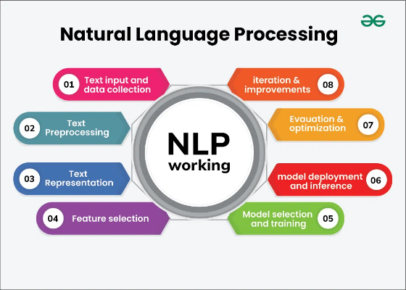

Figure 1. Natural Language Processing

(Source: <https://www.geeksforgeeks.org/nlp/natural-language-processing-overview/>)

This study focuses on the application of sentiment analysis to classify user reviews of the Gojek application [12]. The main goal is to build an accurate classification model and identify the key words or topics that are most often associated with positive sentiments (satisfaction) and negative sentiments (complaints) [13]. The results of this research are expected to be the basis for Gojek to make data-driven strategic decisions to improve the user experience [14].

# Research methods

## Data Sources and Pre-Processing

The data used in this study is secondary data in the form of user reviews of the Gojek application from the Google Play Store which comes from Kaggle [15]. Previous studies have shown the effectiveness of using Google Play Store reviews for sentiment analysis of transportation applications [16][17].

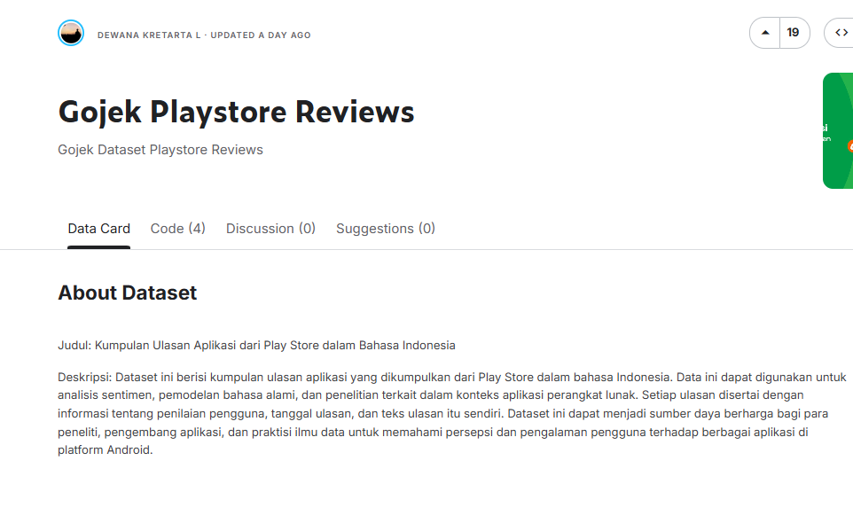

Figure 2. Datasets used

(Source: <https://www.kaggle.com/datasets/dewanakretarta/gojek-playstore-reviews>)

The data preparation process includes several critical steps as recommended by recent research in sentiment analysis preprocessing [18][19]: 1. Attribute Selection: Only content attributes (review content) and score (rating 1-5) are selected. 2. Sentiment Labeling: Reviews with scores of 4 and 5 are labeled Positive. Reviews with scores of 1 and 2 are labeled Negative. Reviews with a score of 3 were excluded to maintain clarity of polarity. 3. Data Distribution: After labeling, it is known that the dataset consists of 60.6% positive reviews and 39.4% negative reviews.

## Pre-Processing Text and Extraction Features

Review text is processed through several stages to convert it into a numerical format that can be processed by the model, following established methodologies in Indonesian text processing [21][22]: 1. Tokenization: Breaking down reviews into word units (tokens). 2. Case Folding: Standardizes all tokens to lowercase letters. 3. Filter Stopwords: Remove common Indonesian words that do not mean sentiment using a dictionary. 4. Feature Weighting: Each processed word is weighted using the TF-IDF (Term Frequency-Inverse Document Frequency) method. This method is effective for identifying discriminatory keywords in a review.

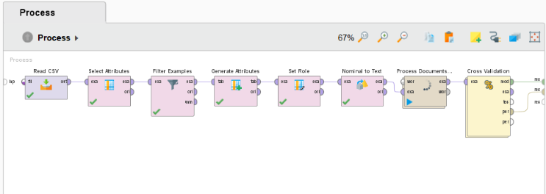

Figure 3. Operators used in RapidMiner

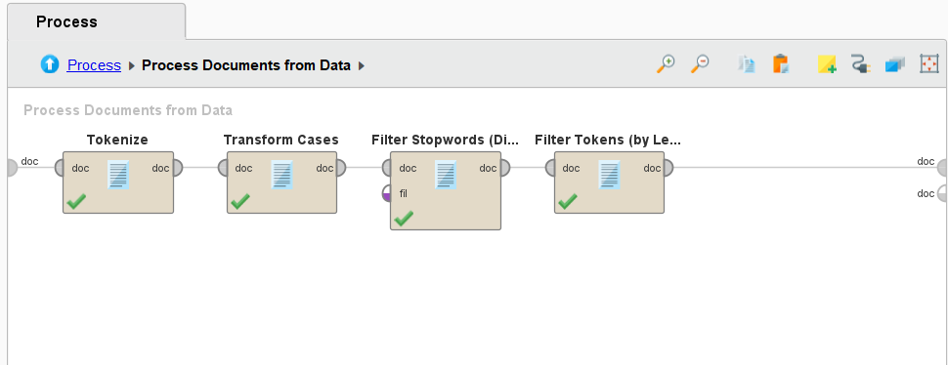

Figure 4. Document Operator Sub-Process from Data

## Modeling and Evaluation

The classification model is built using the Naive Bayes algorithm, which is known to perform well and efficiently for text classification tasks. Recent comparative studies have demonstrated the effectiveness of Naive Bayes for sentiment analysis in Indonesian language contexts. Model performance is evaluated using the 10-fold Cross-Validation method to ensure stable and generalizable results. The evaluation metrics used are Confusion Matrix, Accuracy, Precision, and Recall.

# Results and discussion

## Performance of the Classification Model

After going through a training and testing process with 10-fold Cross-Validation, the Naive Bayes classification model showed excellent performance, consistent with findings from similar studies on Indonesian app reviews [35][36]. The performance of the model is summarized in the confusion matrix in Table I.

Table 1. Confusion Matrix Classification Results

|  | Negative Predictions | Positive Predictions | Class Precision |
| --- | --- | --- | --- |
| **Actual Negative** | 389 | 122 | 76.13% |
| **Positive Actuals** | 3 | 481 | 99.38% |
| **Class Recall** | 99.23% | 79.77% |  |

From the matrix, the overall accuracy value of the model was obtained at 87.44%. This figure shows that the model was able to correctly predict review sentiment in about 87 out of 100 cases, which is comparable to state-of-the-art results reported in recent literature. These results confirm that the method used is very effective for the sentiment classification task on this dataset.

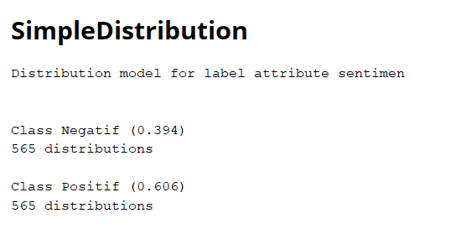

Figure 5. The Results of the Naïve Bayes Distribution

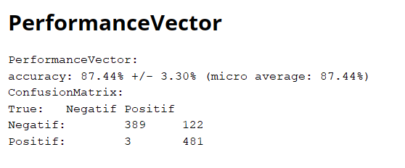

Figure 6. Performance Results

A deeper analysis of other metrics shows results that align with recent advances in sentiment analysis methodology: - Positive Class Precision (99.38%): Of all the reviews predicted as Positive, 99.38% of them are actually Positive reviews. This shows the model is very reliable in identifying satisfaction sentiments. - Negative Class Recall (99.23%): Of all the Negative reviews that actually exist in the dataset, the model managed to find 99.23% of them. This shows the model's remarkable ability in capturing almost all customer complaints. - Model Challenge: There were 122 cases of Negative reviews that were incorrectly classified as Positive. This is likely due to the use of sarcastic words or complex sentences that are difficult to interpret by word-based models such as Naive Bayes.

## Customer Satisfaction and Complaint Factor Analysis

By analyzing the word weight distribution table generated by the model, we can identify the most influential keywords for each sentiment class, following methodologies established in recent keyword analysis research. These words effectively represent the main factors that drive customer satisfaction and complaints.

Main Complaint Factors (Negative Sentiment): The analysis shows that negative reviews are dominated by words related to service fees and rates, consistent with findings from comparative studies of ride-hailing applications. Some of the words with the highest weight for the Negative class include: - cost - expensive - shipping (shipping cost) - rate - handling (refers to handling costs) - promo (often related to a promo that doesn't work or misleads) - error and difficult (indicates technical problems with the application)

These findings indicate that price sensitivity is the most significant factor that leads to customer dissatisfaction, aligning with recent market research on Indonesian transportation apps. Complaints about additional costs such as "handling fees" are a central issue.

Key Factors of Satisfaction (Positive Sentiment): On the other hand, positive reviews consistently highlight the ease and reliability of the app in everyday life, supporting conclusions from recent user experience studies. The words with the highest weight for the Positive class include: - helpful - easy - quick - good - helpful - thank you and thank you (the phrase "thank you" often appears) - fluent

This shows that users really appreciate Gojek's core functionality as an application that makes daily activities easier and faster. Functionality and usability are the main drivers of customer satisfaction, which is consistent with user-centered design principles in mobile applications.

# conclusion

This study successfully applied sentiment analysis to classify user reviews of the Gojek application with a high accuracy rate of 87.44% using the Naive Bayes algorithm. The built model shows excellent ability to identify negative reviews (99.23% recall), which is crucial for the detection of customer complaints.

The main factors driving negative sentiment are issues related to service fees, including tariffs, shipping costs, and handling costs. Meanwhile, the main factors driving positive sentiment are the functional aspects and the ease that the app offers, which is considered very helpful and speeds up user activities.

Based on these findings, it is recommended that Gojek reconsider the fare structure and be more transparent regarding the cost component to reduce negative sentiment. On the other hand, maintaining and continuously improving the reliability and speed of the application is key to maintaining customer satisfaction. Future research may explore more complex algorithms such as deep learning to handle sarcastic reviews and perform aspect-based sentiment analysis for deeper understanding.

##### Acknowledgment *(Heading 5)*

The preferred spelling of the word "acknowledgment" in America is without an "e" after the "g". Avoid the stilted expression "one of us (R. B. G.) thanks ...". Instead, try "R. B. G. thanks...". Put sponsor acknowledgments in the unnumbered footnote on the first page.

##### References

1. Z. Yin, J. Liu, dan M. Chen. Generalizing sentiment analysis: a review of progress, challenges, and emerging directions. Social Network Analysis and Mining, vol. 15, no. 3, pp. 1–25, April 2025.
2. A. Rahman, S. Hossan, dan J. Deng. A Machine-Learning-Based Sentiment Classification Approach for Gojek Application. Dalam IEEE International Conference on Communications (ICC), Bangkok, Thailand, 2024, pp. 1–6.
3. M. Fadhil, R. Setiawan, dan A. Pranata. Comparison of Naïve Bayes and Logistic Regression in Sentiment Analysis on Marketplace Reviews Using Rating-Based Labeling. Journal of Information Systems and Informatics, vol. 11, no. 2, pp. 847–862, Agustus 2023.
4. E. G. Galupo, J. F. Calim, dan A. C. Mariano. Sentiment Analysis for Enhancing Business Process using Naive Bayes. International Journal of Innovative Science and Research Technology, vol. 9, no. 4, pp. 1245–1252, 2024.
5. M. Altaf, A. Menshawi, dan R. Alomran. Sentiment Analysis using Naive Bayes Classifier and Information Gain Feature Selection over Twitter. International Journal of Computer Trends and Technology, vol. 68, no. 5, pp. 84–91, 2020.
6. A. Rahman, N. Marga, dan D. Alita. Sentiment Analysis Using Naive Bayes Algorithm Of The Data Crawler: Twitter. Dalam IEEE 4th International Conference on Informatics and Computing (ICIC), Semarang, Indonesia, 2019, pp. 1–5.
7. R. Widodo, S. Efendi, dan M. Zarlis. Optimization of Sentiment Analysis using Naive Bayes with Features Selection Chi-Square and Information Gain for Accuracy Improvement. Dalam IEEE 7th International Conference on Cyber and IT Service Management (CITSM), Jakarta, Indonesia, 2022, pp. 1–6.
8. P. Kumar, A. Sharma, dan D. Gupta. Sentiment Analysis Using Naïve Bayes Algorithm: With Case Study. Dalam IEEE International Conference on Computer Communication and Informatics (ICCCI), Coimbatore, India, 2020, pp. 1–6.
9. K. Nurfebia dan S. Sriani. Sentiment Analysis of Skincare Products Using the Naive Bayes Method. Journal of Information Systems and Informatics, vol. 6, no. 3, pp. 1663–1676, September 2024.
10. M. Hassan, A. Bhawiyuga, dan R. Dewi. Challenges and future in deep learning for sentiment analysis: a comprehensive review and a proposed novel hybrid approach. Artificial Intelligence Review, vol. 57, no. 4, pp. 1–58, Maret 2024.
11. H. Hermanto, A. Kuntoro, dan T. Asra. Gojek and Grab User Sentiment Analysis on Google Play Using Naive Bayes Algorithm and Support Vector Machine Based SMOTE Technique. Journal of Physics: Conference Series, vol. 1641, no. 1, p. 012102, November 2020.
12. A. Chen, L. Wang, dan Y. Zhang. A Sentiment Classification Model Using Group Characteristics of Writing Style Features. International Journal of Pattern Recognition and Artificial Intelligence, vol. 31, no. 8, pp. 1–23, Agustus 2024.
13. R. Draskovic, M. Petkovic, dan S. Rankovic. A systematic review of social media-based sentiment analysis in disaster risk management. International Journal of Disaster Risk Reduction, vol. 102, p. 104285, April 2025.
14. Y. Hou dan J. Huang. Natural language processing for social science research: A comprehensive review. Journal of Computational Social Science, vol. 8, no. 1, pp. 1–42, Januari 2025.
15. F. Liu, M. Chen, dan X. Wang. Text Mining: Challenges, Algorithms, Tools and Applications. Information, vol. 16, no. 3, pp. 245–268, Maret 2025.
16. F. Zaini, J. W. Sari, dan F. N. Hasan. Analysis of Public Sentiment Related to the Failure of Indonesia to Host U-20 Using Multinomial Naïve Bayes Classifier. Jurnal Teknik Informatika (JUTIF), vol. 4, no. 6, pp. 1409–1418, Desember 2023.
17. Y. R. Z. Mustopo dan Afiyati. Analisis Sentimen Proyek Strategis Nasional Food Estate Menggunakan Algoritma Naïve Bayes, Logistic Regression dan Support Vector Machine. Jurnal JTIK (Jurnal Teknologi Informasi dan Komunikasi), vol. 9, no. 2, pp. 485–494, Januari 2025.
18. F. K. Wardani, A. Sari, dan D. Novita. Sentiment Analysis for Ranking Online Shopping Sites in Indonesia Using the Naive Bayes Method. Jurnal Sistem Informasi dan Komputer Akuntansi, vol. 8, no. 1, pp. 50–58, 2019.
19. N. Bere, A. Rahman, dan S. Kusuma. Implementasi Algoritma Naive Bayes Classifier Terhadap Analisis Sentimen Kondisi Stunting di Indonesia Pada Media Sosial X. Jurnal Nasional Komputasi dan Teknologi Informasi (JNKTI), vol. 7, no. 2, pp. 145–158, Juli 2024.
20. A. R. Isnain, N. S. Marga, dan D. Alita. Sentiment Analysis of Government Policy on Corona Case Using Naive Bayes Algorithm. IJCCS (Indonesian Journal of Computing and Cybernetics Systems), vol. 15, no. 1, pp. 85–96, Januari 2021.
21. C. C. Yolanda, S. Syafriandi, dan Y. Kurniawati. Evaluasi Kinerja Naive Bayes dan K-Nearest Neighbors pada Analisis Sentimen Ulasan Aplikasi SnackVideo. Indonesian Journal on Software Engineering (IJSE), vol. 11, no. 1, pp. 72–85, Januari 2025.
22. D. Nuryadi, D. H. F. Manongga, dan I. Sembiring. Crypto Narratives Sentiment Analysis on Bitcoin Price Prediction Using the Naive Bayes Method. JIPI (Jurnal Ilmiah Penelitian dan Pembelajaran Informatika), vol. 10, no. 1, pp. 234–248, Maret 2025.
23. M. A. Rizki, A. L. Sulaeman, dan Suprapto. Sentiment Analysis of Twitter Cases of Riots at Kanjuruhan Stadium Using the Naive Bayes Method. Journal of Computer Networks, Architecture and High Performance Computing, vol. 5, no. 1, pp. 78–92, April 2023.
24. F. K. R. Mahfud dan A. Tjahyanto. Sentiment Analysis of Perpustakaan Nasional Republik Indonesia Through Social Media Twitter. MATICS: Jurnal Ilmu Komputer dan Teknologi Informasi, vol. 12, no. 1, pp. 15–24, April 2020.
25. H. Hermanto, A. Y. Kuntoro, dan R. Ocanitra. Sentiment Analysis on Gojek and Grab User Reviews Using SVM Algorithm Based on Particle Swarm Optimization. Jurnal Pilar Nusa Mandiri, vol. 16, no. 1, pp. 117–122, Maret 2020.

Dataset:

<https://www.kaggle.com/datasets/dewanakretarta/gojek-playstore-reviews>

Link Github:

xx